ONEWAY CRT BY HOS
/STATISTICS DESCRIPTIVES HOMOGENEITY WELCH
/PLOT MEANS
/MISSING ANALYSIS.

Oneway

Notes
Output Created |  | 05-May-2019 23:36:31
Comments
Input | Active Dataset | DataSet0
Input | Filter | <none>
Input | Weight | <none>
Input | Split File | <none>
Input | N of Rows in Working Data File | 30
Missing Value Handling | Definition of Missing | User-defined missing values are treated as missing.
Missing Value Handling | Cases Used | Statistics for each analysis are based on cases with no missing data for any variable in the analysis.
Syntax |  | ONEWAY CRT BY HOS  /STATISTICS DESCRIPTIVES HOMOGENEITY WELCH  /PLOT MEANS  /MISSING ANALYSIS.
Resources | Processor Time | 00 00:00:00.156
Resources | Elapsed Time | 00 00:00:00.164

[DataSet0]

Descriptives
 | N | Mean | Std. Deviation | Std. Error
Between 7-5 hours of sleep | 8 | 9.7500 | 2.90763 | 1.02800
Between 7-9 hours of sleep | 8 | 7.0000 | 3.13688 | 1.10905
Less than 5 hours of sleep | 7 | 8.7714 | 3.46685 | 1.31035
More than 9 hours of sleep | 7 | 9.1000 | 3.80920 | 1.43974
Total | 30 | 8.6367 | 3.32291 | .60668

Descriptives
 | 95% Confidence Interval for Mean |  | Minimum | Maximum
 | Lower Bound | Upper Bound | Minimum | Maximum
Between 7-5 hours of sleep | 7.3192 | 12.1808 | 4.40 | 13.60
Between 7-9 hours of sleep | 4.3775 | 9.6225 | 3.80 | 12.40
Less than 5 hours of sleep | 5.5651 | 11.9777 | 3.20 | 12.00
More than 9 hours of sleep | 5.5771 | 12.6229 | 4.50 | 14.00
Total | 7.3959 | 9.8775 | 3.20 | 14.00

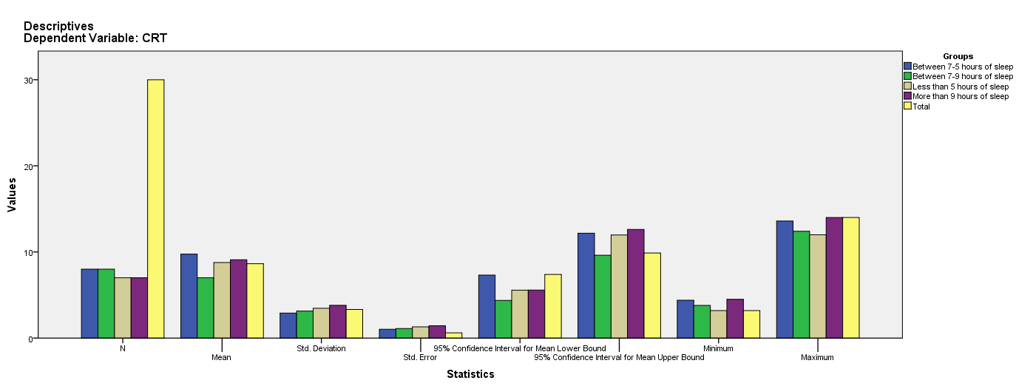

Test of Homogeneity of Variances
CRT
Levene Statistic | df1 | df2 | Sig.
.702 | 3 | 26 | .560

ANOVA
CRT
 | Sum of Squares | df | Mean Square | F | Sig.
Between Groups | 32.975 | 3 | 10.992 | .995 | .411
Within Groups | 287.234 | 26 | 11.047
Total | 320.210 | 29

Robust Tests of Equality of Means
CRT
 | Statisticª | df1 | df2 | Sig.
Welch | 1.055 | 3 | 14.076 | .399
a. Asymptotically F distributed.

Means Plots

